New Co-ordinator for Silver Wattle Quaker Centre

It is with joy & gratitude that we announce the appointment of Brydget Barker-Hudson as the new Co-ordinator of the Silver Wattle Quaker Centre in Bungendore Australia, from mid February 2020 for two years.
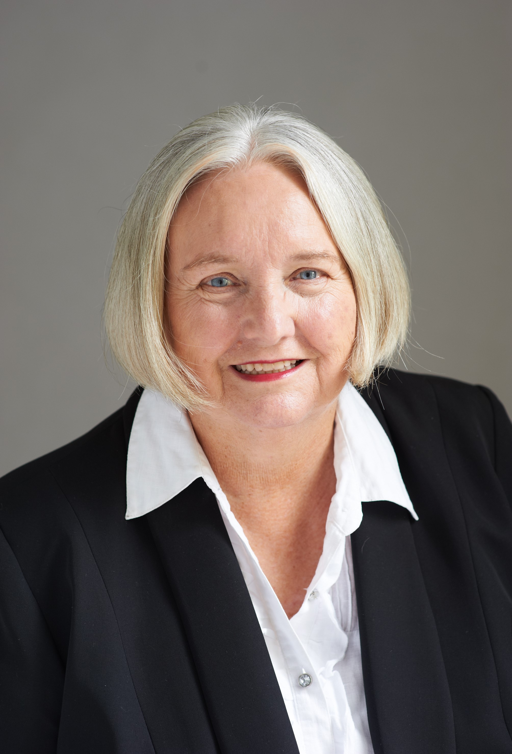
Brydget has been associated with the Religious Society of Friends since 1994, attending Quaker Meetings in Darwin, Adelaide and Townsville. She brings extensive professional experience in mediation, restorative justice and cross-cultural communication, with a diverse background in law and biology, across government, non-government and private sectors. Originally from the UK, Brydget grew up in a strong pacifist tradition and spent a number of years working in Papua New Guinea with her late husband.
With a people-focussed interest in ideas and the beauty of life, Brydget’s calling to this role is a gift to Australian Quakers and the broader community.
Brydget will be assisted in her transition by Felicity Rose who has been acting as Silver Wattle Centre Director over the past year. We look forward to Felicity continuing her association with Silver Wattle, humbled by the nurturing role she has played to uphold the spirit of Silver Wattle through challenging times.
Silver Wattle is blessed with strong foundations, a loving community and a promising future.

More info about Brydget with her introductory letter is available HERE.

Brydget says:
I come to Silver Wattle wishing to progress the development of the Centre enabled through skills and experience from a diverse career and life experiences.
I look forward to extending our team and facilitating the development of spiritual and residential courses and retreats consistent with Quaker aims and values. I will continue some dispute resolution assignments, as they can be fitted into other duties. Although, I fear the cold tremendously after 50 years in the tropics, I look forward to the warmth and fellowship which I am sure I will receive, and support of all, in the further development of Silver Wattle.

